Town centre trams arrive in 2012
August 07, 2010

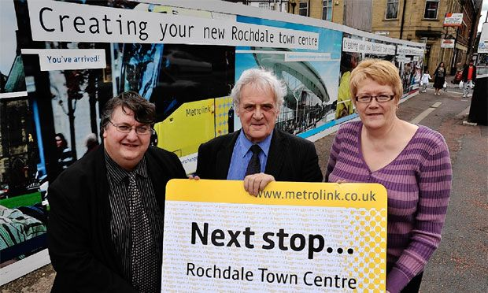
Councillor Keith Whitmore, vice chairman of GMITA, councillor Ian Macdonald, chairman of GMITA and councillor Irene Davidson.
Metrolink will run to Rochdale town centre after half a billion pounds of funding was finally approved.
It is hoped trams will be running along Drake Street to Smith Street in four years after council chiefs approved funding.
Work is already underway to bring the Metrolink as far as Rochdale train station, with the line expected to open in 2012.
At a meeting of the Association of Greater Manchester Authorities (AGMA), leaders of the ten local authorities confirmed funding of £0.5b from the Greater Manchester Transport Fund for three new tram lines, including a £35.5m payment to extend the Rochdale line from the train station, down Drake Street and into the town centre.
GMPTE has appointed MPact Thales (MPT) to design, construct and maintain the new lines, which as well as Rochdale will also run to Oldham town centre and Manchester Airport.
MPT, a consortium of Laing O’Rourke, VolkerRail and Thales UK, has already begun work on the new lines and anticipate the Rochdale town centre line will be up and running by spring 2014.
Leader of Rochdale Council, Councillor Irene Davidson, said: "It’s fantastic news for Rochdale that AGMA has confirmed this funding.
"The extension from the train station to the town centre, along with the development of the transport interchange in Smith Street, will mean it will be easier than ever for people to travel to and from Rochdale.
"It provides a great alternative for car users and will help alleviate congestion on approaches to the town centre.
"The extension also supports our plans for the town centre redevelopment.
"The Metrolink stop will be in Smith Street close to the new council building housing the customer service centre and public library, and it is next to the area that will be the focus for the new retail and leisure development, benefiting both current and future town centre businesses and shoppers.
"The line will also help people to get from the train station to the town centre, making it easier for those who are travelling beyond the borough for employment to use public transport.
"It’s a win-win for everyone; residents, businesses and visitors to Rochdale."
David Leather, chief executive of GMPTE, said: "This milestone in Metrolink history will see the system almost treble compared to today’s network.
"With the support of our delivery partner, Parsons Brinckerhoff, and the experience of MPT, we are confident of successful delivery of the new lines."
An extra 14 new trams have been ordered to serve the three extensions, in addition to a further 48 which have been ordered for the entire network.
Source; GMPTE

